APEX PL/SQL

- B.SHASHANK

192324123

**Creation of employee table** CREATE TABLE employee (

employee_id NUMBER GENERATED BY DEFAULT AS IDENTITY PRIMARY KEY,

first_name VARCHAR2(50) NOT NULL, last_name VARCHAR2(50) NOT NULL

);

**Insert the values one by one**

INSERT INTO employee (first_name, last_name) VALUES ('John', 'Doe');

INSERT INTO employee (first_name, last_name) VALUES ('Jane', 'Smith');

INSERT INTO employee (first_name, last_name) VALUES ('Emily', 'Johnson');

**Creation of audit table:**

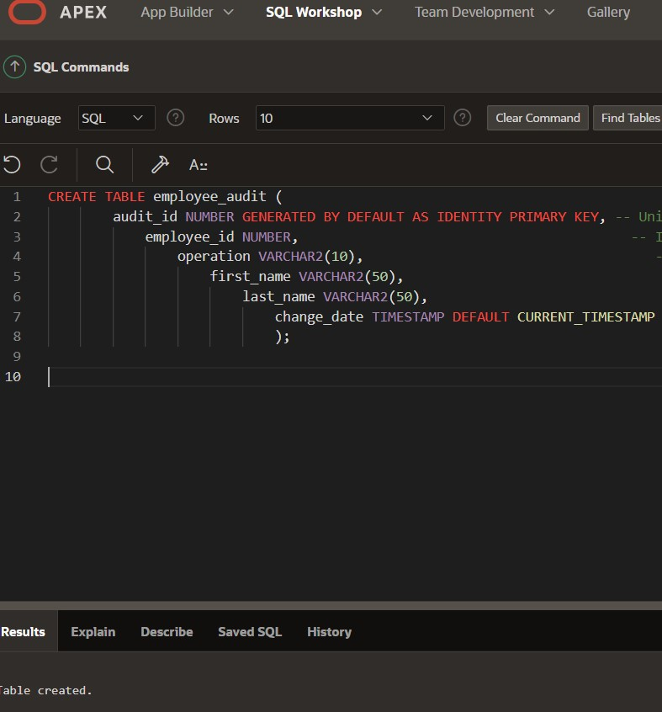

**Create a trigger**

